Nama : Ilham Maulana Ramadhan

Nim : 1207070058

Matkul : PCD TSEB

Link Github : <https://github.com/ilhamchuaks/Praktikum-08_Ilham-Maulana-Ramadhan.git>

**PRAKTIKUM 08 TRANSFORMASI CITRA**

1. Transformasi Twirl

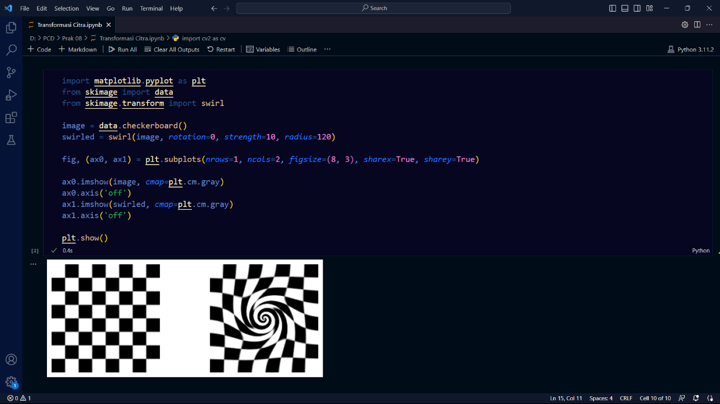

1. Translation

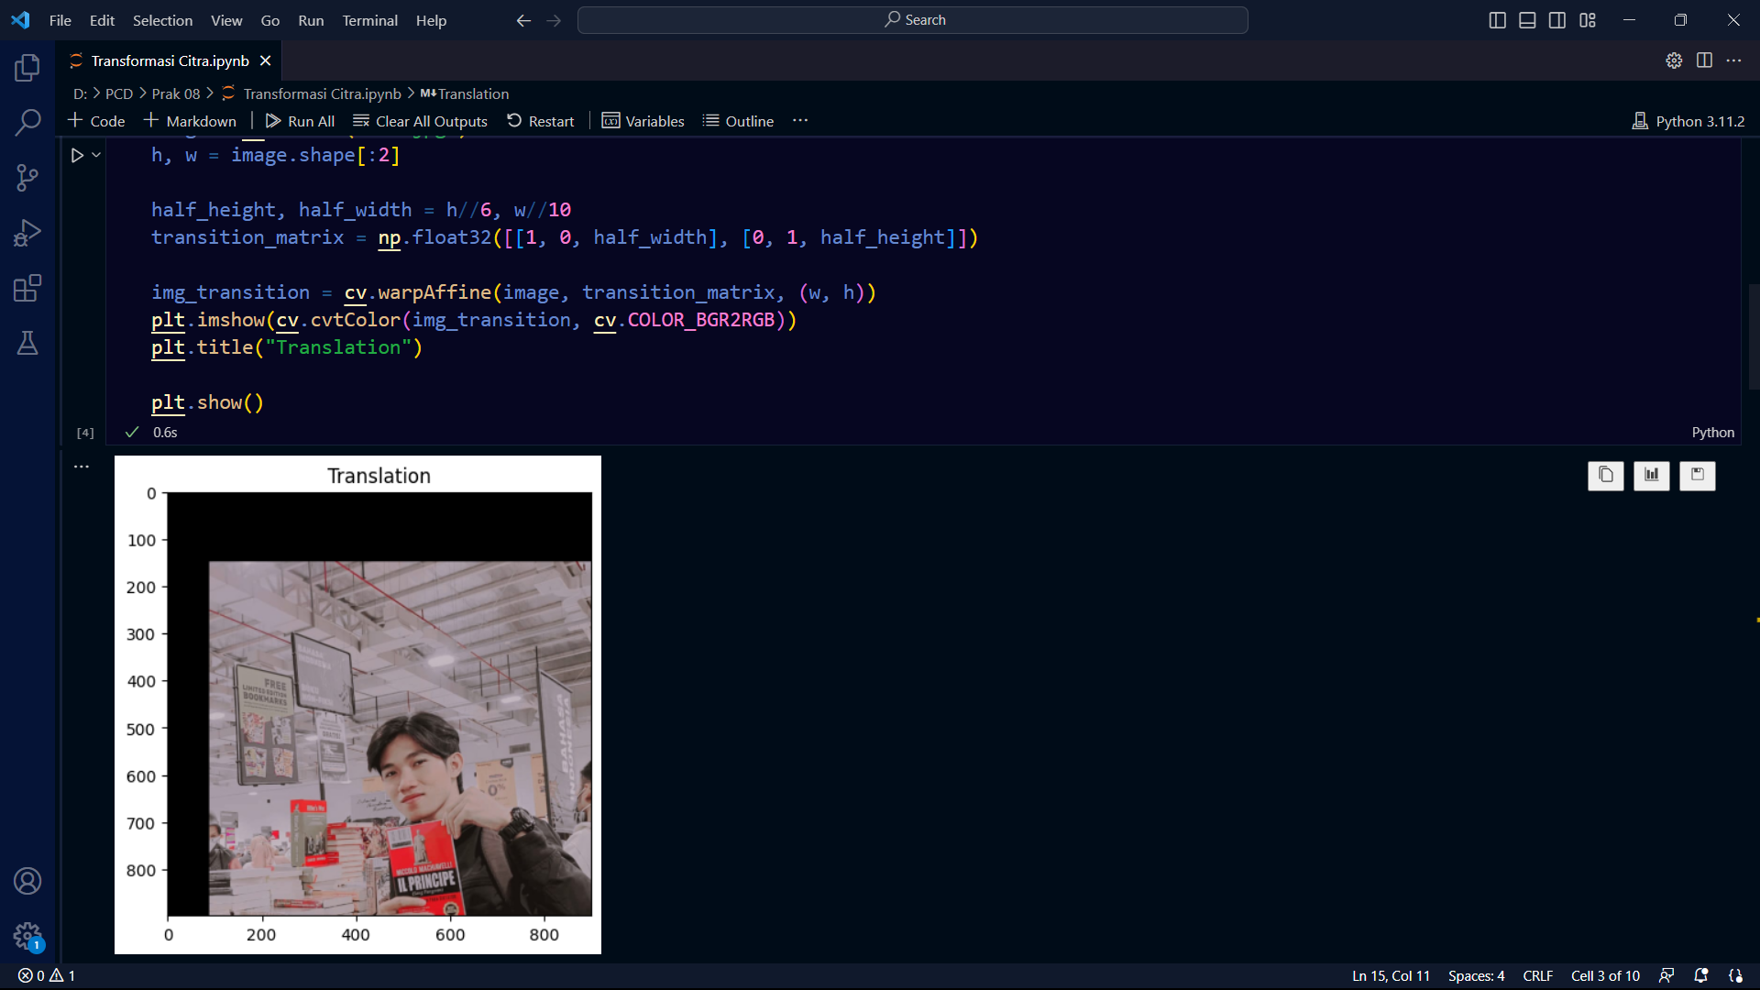

1. Rotation

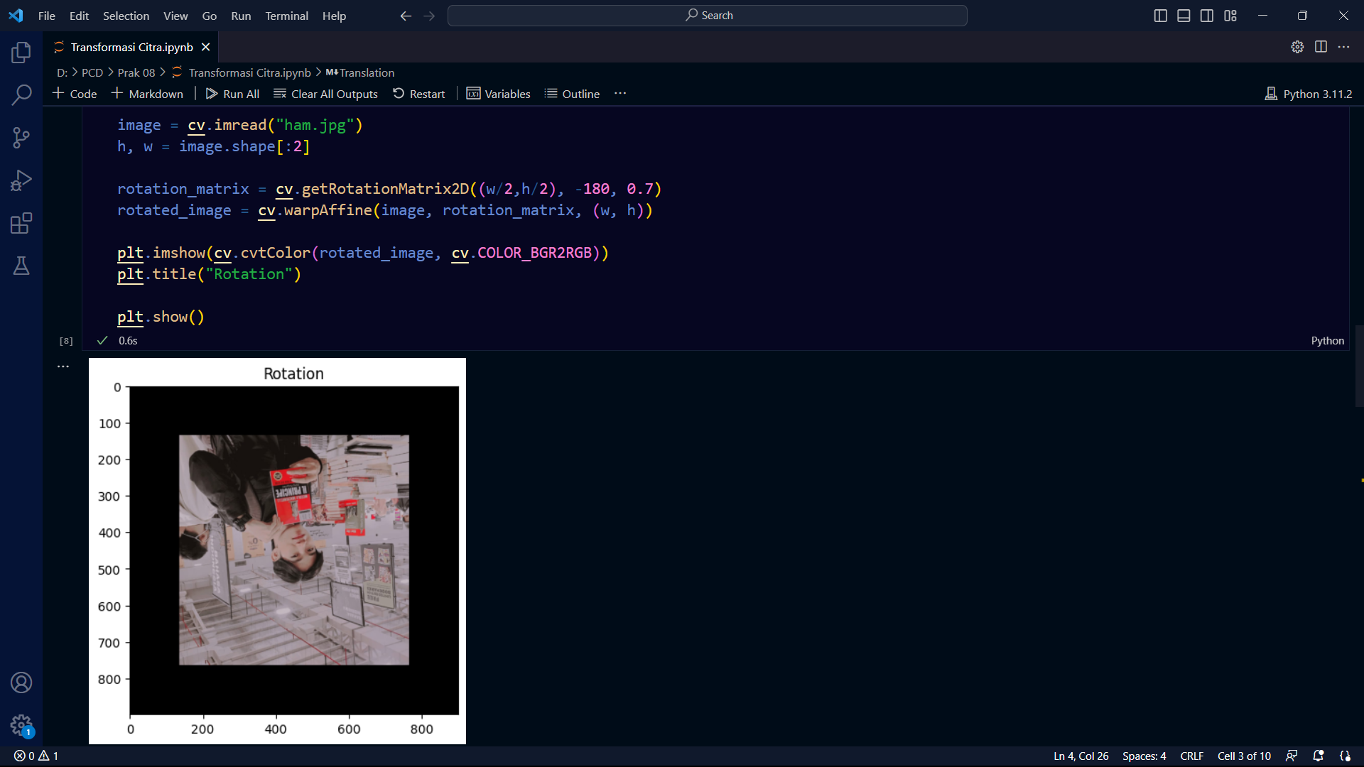

1. Interpolation

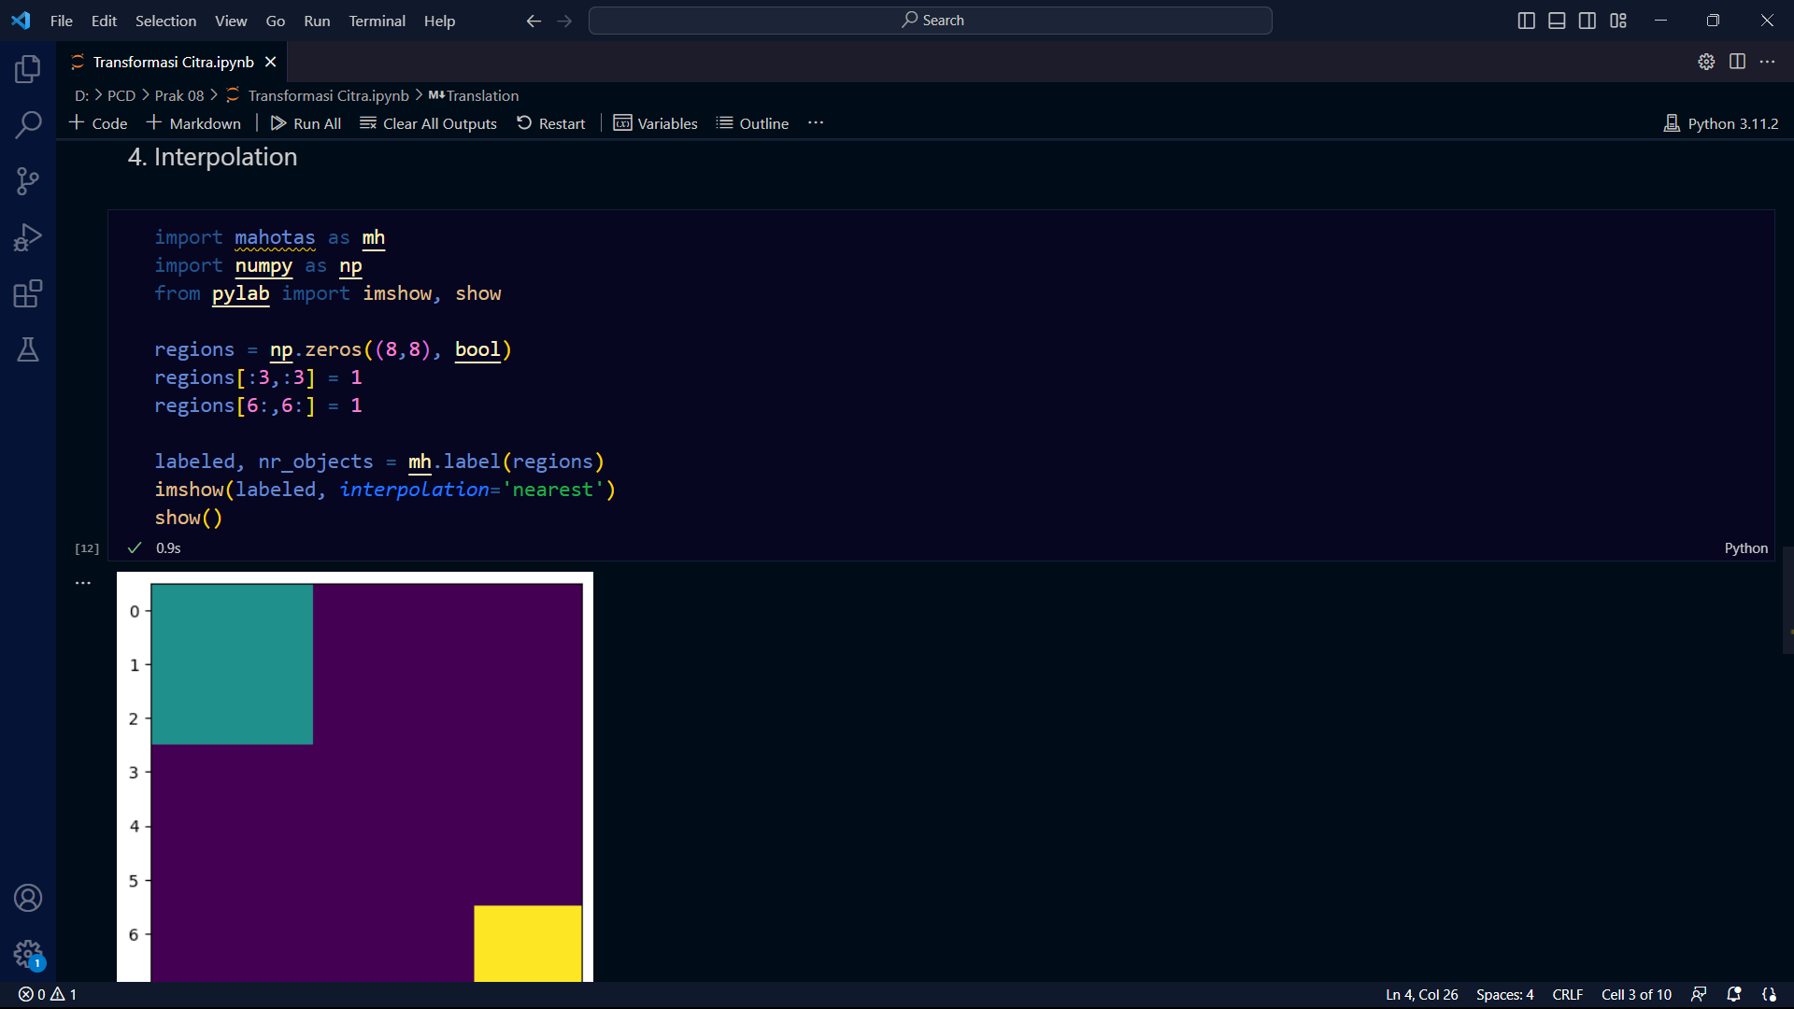

1. Skala Interpolation Miring

